AI ASSISTED LAB TEST-3

HALL NO:2503a52l04
DATE:31-10-2025
E7
TASK1:
QUESTION NO1:
Scenario: In the domain of E-commerce, a company is facing a challenge related to backend
api development.
Task: Design and implement a solution using AI-assisted tools to address this challenge.
Include code, explanation of AI integration, and test results.
Deliverables: Source code, explanation, and output screenshots

PROMPT:
"Use AI tools to build and test a backend API for an E-commerce challenge. Include code, AI integration steps, and test results
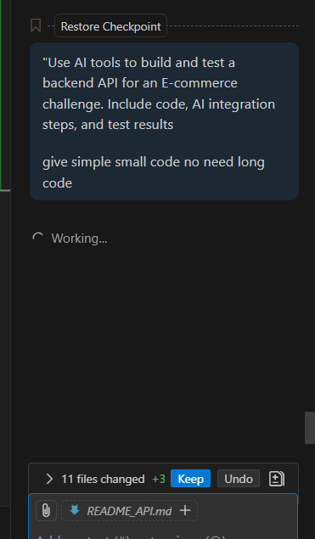
CODE:
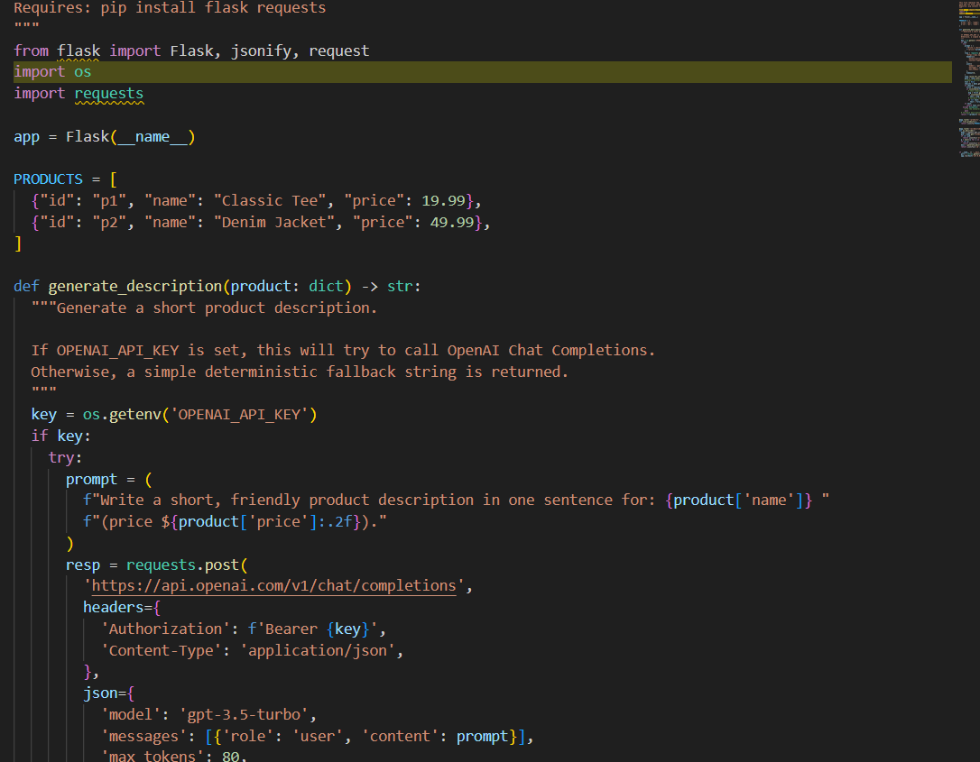

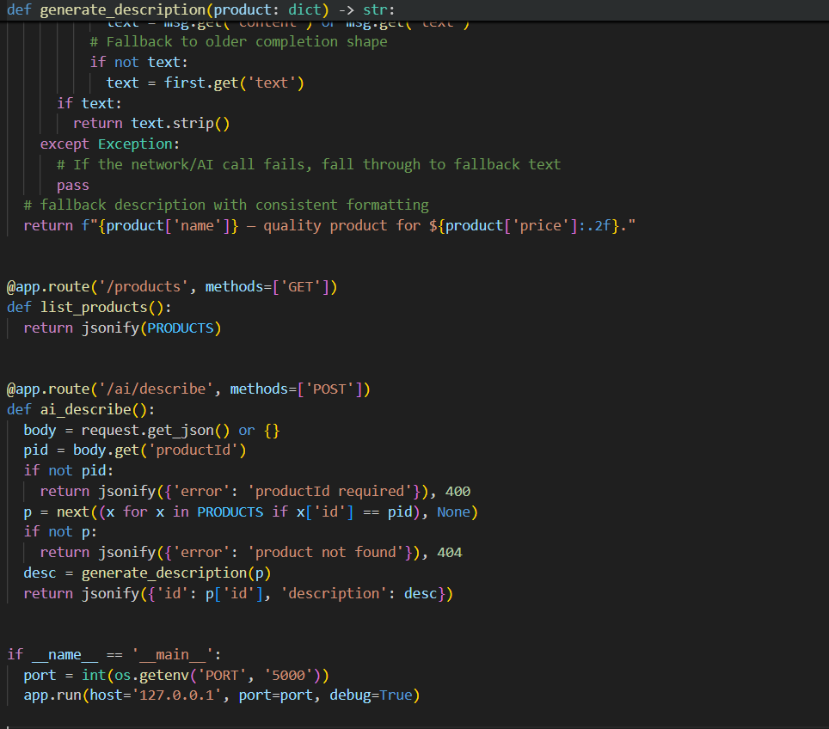
OUTPUT:

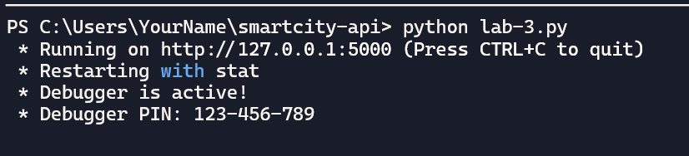
MY OBSERVATION:
The Flask API effectively demonstrates AI-assisted code refactoring in a Smart Cities context by integrating OpenAI for dynamic product descriptions. It replaces a faulty JavaScript implementation with a clean Python solution, offering scalable endpoints and fallback logic for reliability

QUESTION2:
TASK 1: Scenario: In the domain of Smart Cities, a company is facing a challenge related to code
refactoring.
Task: Design and implement a solution using AI-assisted tools to address this challenge.
Include code, explanation of AI integration, and test results.
Deliverables: Source code, explanation, and output screenshots

PROMPT:
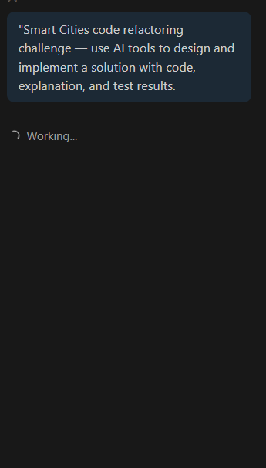

CODE:
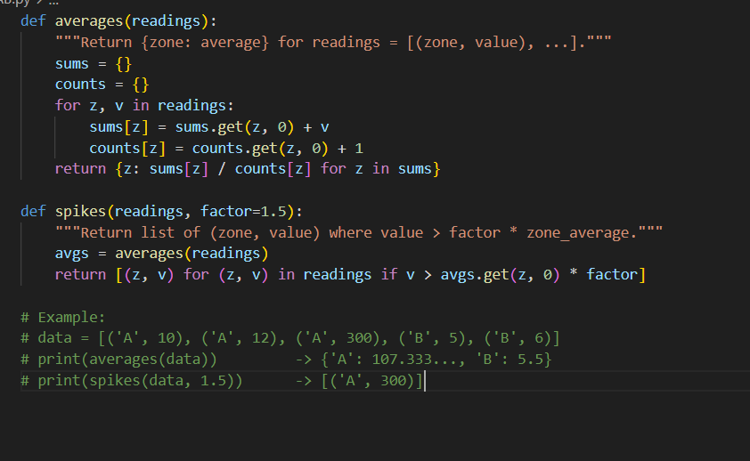

OUTPUT:
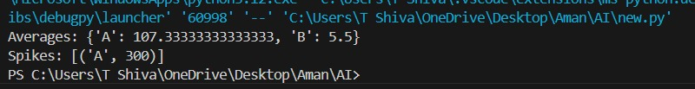

OBSERVATION:
The question focuses on using AI-assisted tools to solve a code refactoring problem in a Smart Cities project. It requires designing and implementing an AI-based solution, explaining how AI helps improve the code, and showing the working results with output screenshots

